OOP Lab: Experiment 10

Submitted By: Aryan Saxena

Batch: B1

SAP Id: 500082431

Roll No.: R214220274

**Exercise 1:** Write a program for the following

* Read all elements from ArrayList by using Iterator.
* Create duplicate object of an ArrayList instance.
* Reverse ArrayList content.

## Code:

import java.util.*;

public class ArrayListIterator

{

    public static void main(String[] args)

    {

        ArrayList<Integer> arr = new ArrayList<Integer>();

        arr.add(10);

        arr.add(20);

        arr.add(30);

        Iterator<Integer> Itr = arr.iterator();

        while(Itr.hasNext())

        {

            System.out.println(Itr.next());

        }

        System.out.println(arr);

        ArrayList<Integer> SecondArray = (ArrayList<Integer>) arr.clone();

        System.out.println(SecondArray);

        Collections.reverse(arr);

        System.out.println(arr);

    }

}

## Output:

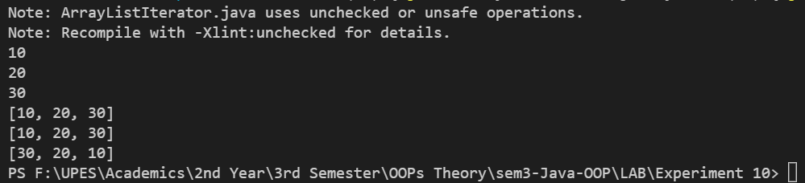

**Exercise 2:** Write a program for the following HashMap

* find whether specified key exists or not.
* find whether specified value exists or not
* get all keys from the given HashMap
* get all key-value pair as Entry objects

## Code:

import java.util.*;

public class HashHash

{

    public static void main(String[] args)

    {

        Scanner SC1 = new Scanner(System.in);

        HashMap<Integer, String> map = new HashMap<Integer, String>();

        map.put(99, "Ninty Nine");

        map.put(100, "Hundred");

        map.put(200, "Two Hundred");

        System.out.println(map);

        System.out.print("Enter Key: ");

        int k = SC1.nextInt();

        if(map.containsKey(k))

            System.out.println("Key present!");

        else

            System.out.println("Key not present!");

        System.out.print("Enter Value: ");

        String v = SC1.next();

        if(map.containsValue(v))

            System.out.println("Value Present!");

        else

        System.out.println("Value not present!");

        System.out.println("\nAll Keys-");

        for(Integer m: map.keySet())

        {

            System.out.println(m);

        }

        System.out.println("\nKey-Value Pairs-");

        for(Map.Entry<Integer, String> m: map.entrySet())

        {

            System.out.println(m.getKey() + ": " +m.getValue());

        }

    }

}

## Output:

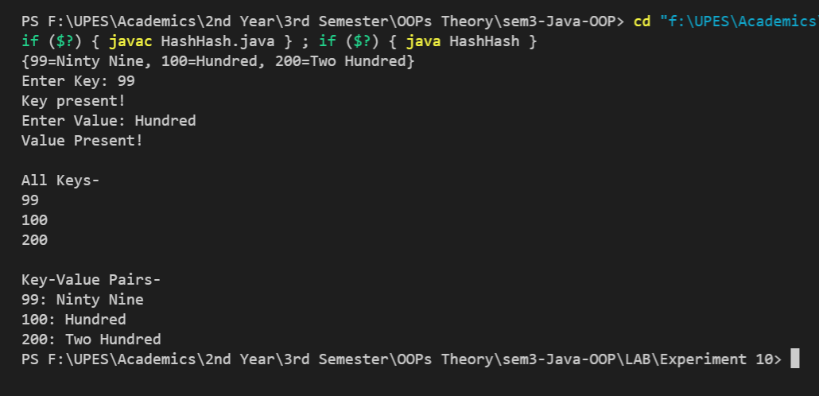

**Exercise 3:**

## Code:

import java.util.*;

public class HashHashSet

{

    public static void main(String[] args)

    {

        int UserInput;

        HashSet<Integer> OriginalSet = new HashSet<Integer>();

        HashSet<Integer> CopySet = new HashSet<Integer>();

        OriginalSet.add(15);

        OriginalSet.add(30);

        OriginalSet.add(45);

        CopySet.add(60);

        CopySet.add(75);

        OriginalSet.addAll(CopySet);

        System.out.println("Set: "+OriginalSet+"\n");

        Scanner sc = new Scanner(System.in);

        System.out.println("Enter Object: ");

        UserInput= sc.nextInt();

        Integer i  = Integer.valueOf(UserInput);

        if(OriginalSet.contains(i))

            System.out.println("Present!");

        else

            System.out.println("Not Present");

        OriginalSet.clear();

        OriginalSet.clear();

        System.out.println("All Entries deleted! ");

        System.out.println("\nSet: "+OriginalSet);

    }

}

## Output:

